WEEK – 2

Exercise 1: Mocking and Stubbing

Nipuna.A

Superset id: 6432842

Scenario:

You need to test a service that depends on an external API. Use Mockito to mock the external API and stub its methods.

Steps:

1. Create a mock object for the external API.
2. Stub the methods to return predefined values.
3. Write a test case that uses the mock object.

Solution Code:

import static org.mockito.Mockito.\*; import org.junit.jupiter.api.Test; import org.mockito.Mockito;

public class MyServiceTest { @Test

public void testExternalApi() {

ExternalApi mockApi = Mockito.mock(ExternalApi.class); when(mockApi.getData()).thenReturn("Mock Data"); MyService service = new MyService(mockApi);

String result = service.fetchData(); assertEquals("Mock Data", result);

}

}

Solution:

* Src

Main\java\com\example

1)ExternalApi.java:

package com.example;

public interface ExternalApi {

    String getData();

}

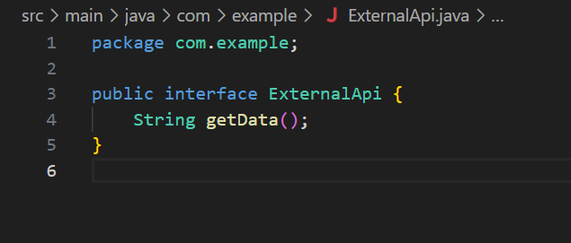

2)MyService.java

package com.example;

public class MyService {

    private ExternalApi api;

    public MyService(ExternalApi api) {

        this.api = api;

    }

    public String fetchData() {

        return api.getData();

    }

}

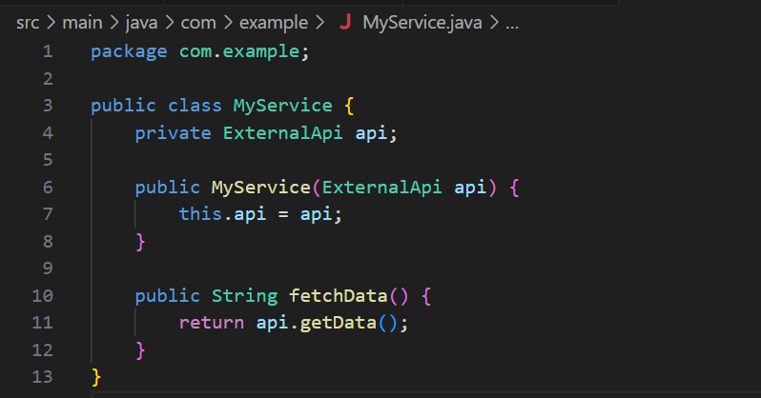

Test\java\com\example

1)MyServiceTest.java

package com.example;

import static org.mockito.Mockito.\*;

import static org.junit.jupiter.api.Assertions.\*;

import org.junit.jupiter.api.Test;

import org.mockito.Mockito;

public class MyServiceTest {

    @Test

    public void testExternalApi() {

        ExternalApi mockApi = Mockito.mock(ExternalApi.class);

        when(mockApi.getData()).thenReturn("Mock Data");

        MyService service = new MyService(mockApi);

        String result = service.fetchData();

        assertEquals("Mock Data", result);

    }

}

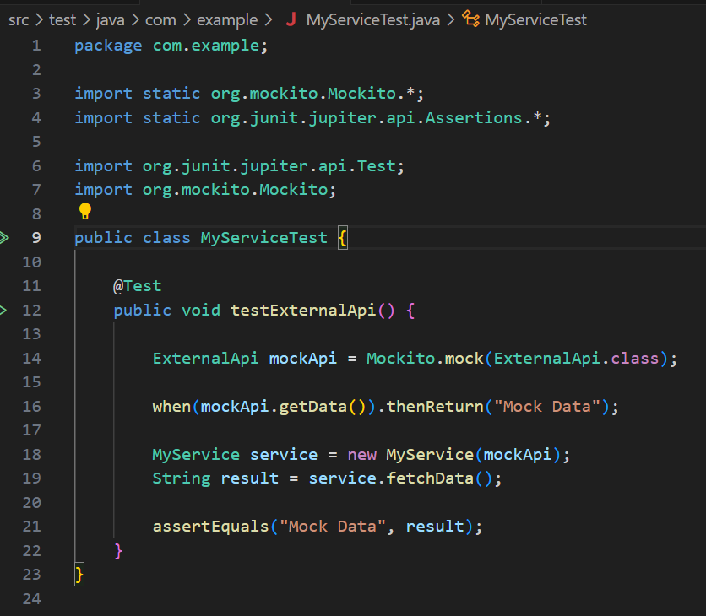

Pom.xml:

<project xmlns="http://maven.apache.org/POM/4.0.0"

         xmlns:xsi="http://www.w3.org/2001/XMLSchema-instance"

         xsi:schemaLocation="http://maven.apache.org/POM/4.0.0 http://maven.apache.org/xsd/maven-4.0.0.xsd">

    <modelVersion>4.0.0</modelVersion>

    <groupId>com.example</groupId>

    <artifactId>MockingAndStubbingExample</artifactId>

    <version>1.0-SNAPSHOT</version>

    <dependencies>

        <!-- JUnit 5 -->

        <dependency>

            <groupId>org.junit.jupiter</groupId>

            <artifactId>junit-jupiter</artifactId>

            <version>5.10.0</version>

            <scope>test</scope>

        </dependency>

        <!-- Mockito -->

        <dependency>

            <groupId>org.mockito</groupId>

            <artifactId>mockito-core</artifactId>

            <version>5.11.0</version>

            <scope>test</scope>

        </dependency>

    </dependencies>

    <build>

        <plugins>

            <!-- Surefire plugin for running tests -->

            <plugin>

                <groupId>org.apache.maven.plugins</groupId>

                <artifactId>maven-surefire-plugin</artifactId>

                <version>3.0.0</version>

            </plugin>

        </plugins>

    </build>

</project>

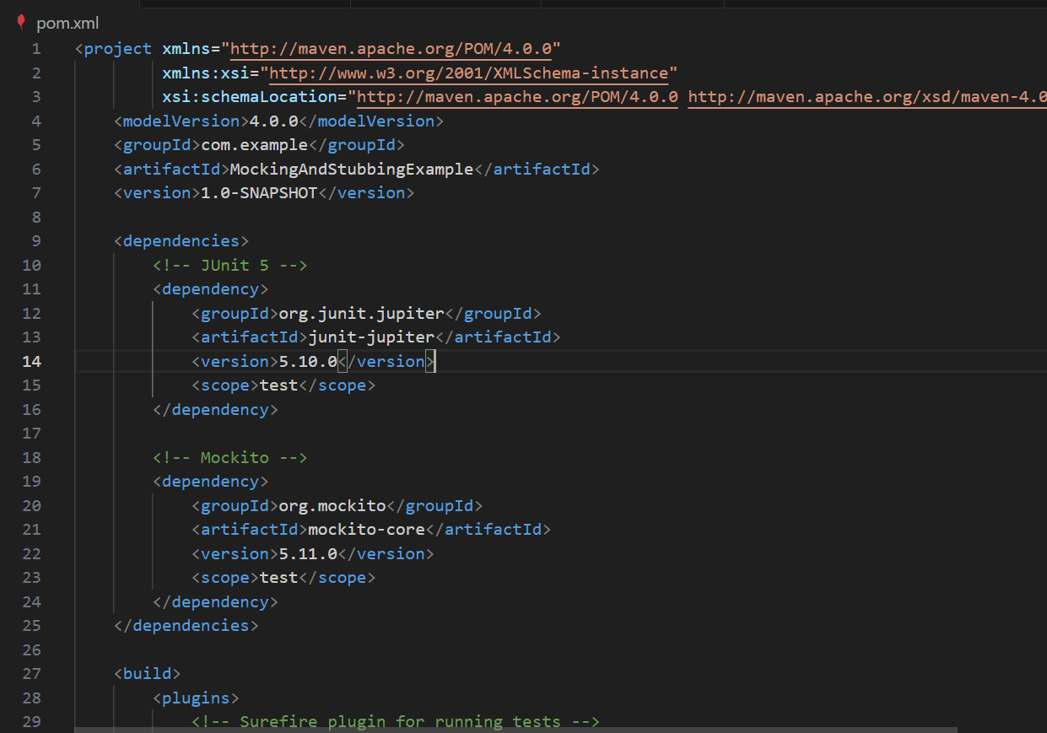

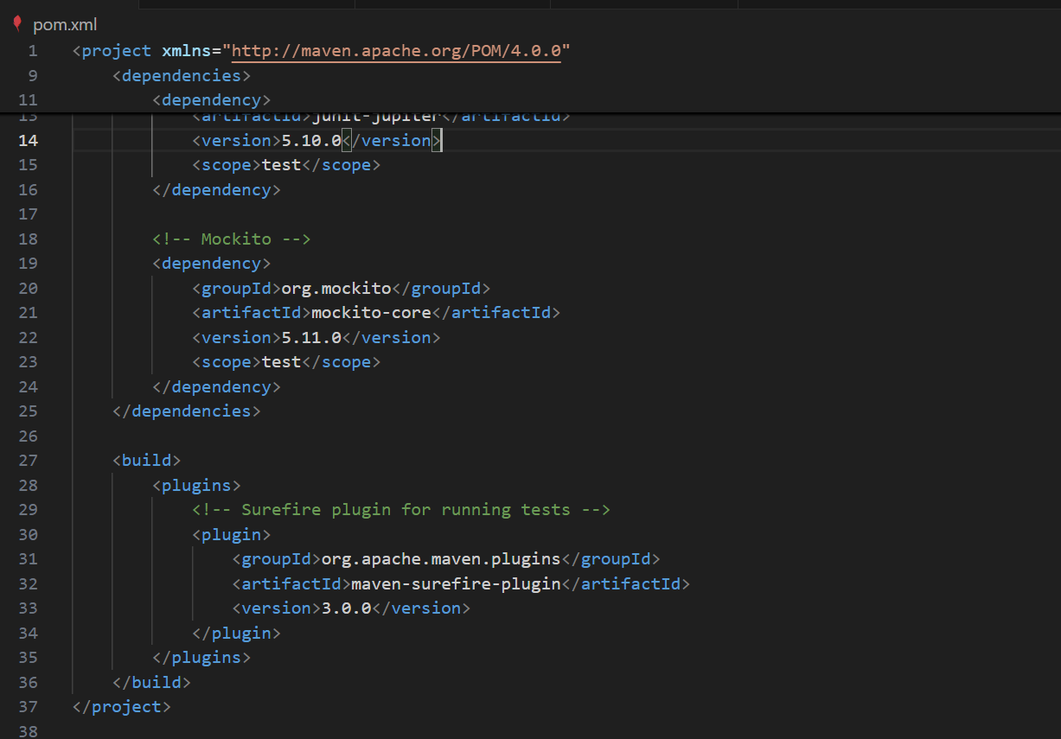

Output:

